Practical Activity and Record: One

Response to a Design Brief: Will it fill me up?
Read the forum post below:
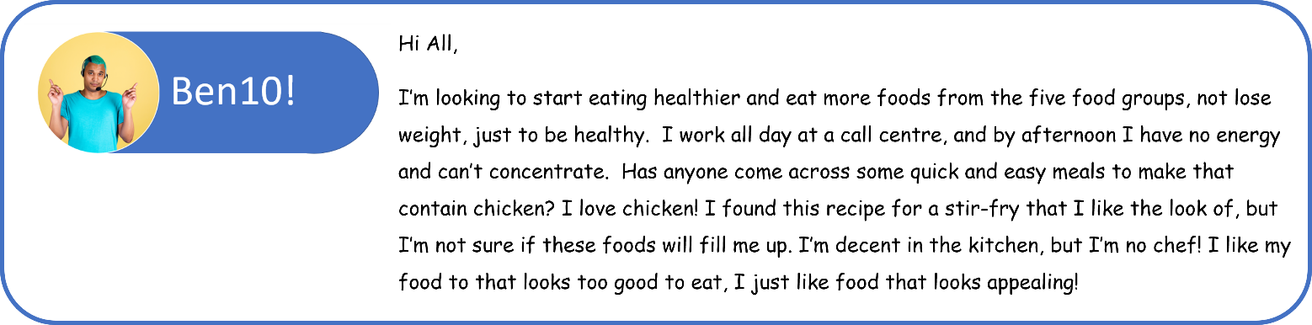
Your task is to design a meal for Ben that meets the criteria listed below.
Ben’s meal must:
- Be healthy and contain foods from the five food groups;
- Fill him up, give him some energy and help him maintain concentration at work;
- Be quick and easy to make.
- Contain chicken;
- Use the stir-fry recipe at the link below; and
- Look appealing.
Click here to access the stir-fry recipe that Ben likes.
Note: Substitute the sweet sherry in the recipe with 2 teaspoons water, 2 teaspoons apple cider vinegar, and a pinch of sugar.

Step 1
Your task is to modify this recipe with ingredients that are high in protein, low in GI, and high in fibre.
Click here to access a database where you can search for the GI value of food. Foods in the database with GI values less than or equal to 55 are considered low GI.
Brainstorm some ingredients you could use in the stir-fry and record them in the table below.
High in protein | Low in GI | High in fibre

Step 2
Fill in the recipe template for the stir-fry you will make.

Step 3
Make the stir-fry in class.

Step 4
- Conduct a sensory evaluation of your stir-fry using the diagram below:
- Mark a dot on the continuum that best represents how you feel the food meets each desired sensory characteristic.
- After rating the sensory characteristics of each sample food, join the dots together.
- The more the dots represent a hexagon shape, the more the food product evaluated meets the sensory characteristics listed.
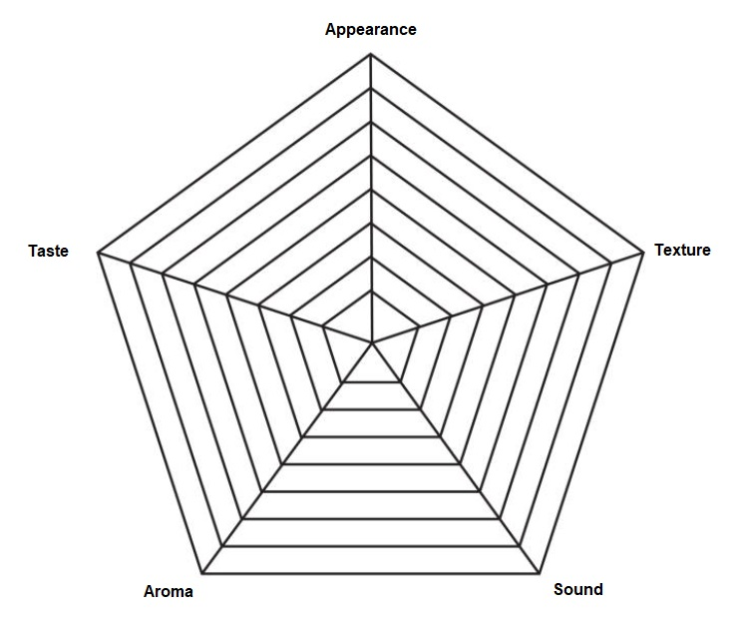
- Use descriptive words to describe the sensory properties of your stir-fry in the table below.
Appearance | Texture | Sound | Aroma | Taste
- In the table below, discuss how the stir-fry you made best met the criteria in the design brief.
Design Brief Criteria | In what ways did or didn’t you meet this criterion?
Be healthy and contain foods from the five food groups;
Fill him up, give him some energy and help him maintain concentration at work;
Be quick and easy to make.
Contain chicken;
Use the stir-fry recipe at the link below; and
Look appealing.

Recipe Template
Student Name: |  | Recipe Name:
Source/ Weblink: | (please print)
Serves: |  |  | Cooking Method: | (no deep-frying)
Preparation Time: |  |  | Cooking Time:
Food Order: (include ingredient measurements and quantities)
Fruits and Vegetables | Meat, Fish and/or Poultry |  | Refrigerator/ Freezer |  | Pantry
Specialised Equipment:
Method:
Safety Rules: |  |  | Process/ Terms:

Practical Activity and Record Two

Sensory Analysis
Sensory analysis is also called a sensory evaluation or sensory test. Sensory analyses help describe the physical properties of food and determine how well-liked a food product is. In the food industry, approximately 100 people would be employed to participate in sensory taste tests.
This task involves completing a range of sensory taste tests as a means to explore the sensory appreciation of different foods. Completing this task will give you the required skills to undertake sensory tests in school-assessed coursework throughout the year; however, you will not be asked to remember the specific types of tests.

Test A: Conducting a Preference (Hedonic Scale) Sensory Test
Preference sensory tests supply information about people’s preferences for a food product. A hedonic rating scale is a type of preference test. The term hedonic means having to do with pleasure, so rating scales with likes or dislikes are called hedonic rating scales. They involve rating food to determine how much sensory testers like or dislike a food product.
Aim: To determine the extent of liking/appreciation for three foods.
Materials per student:
1 tray |  |  | 1 glass of water |  | 1 record sheet
3 varieties of food
Procedure:
The person conducting the test arranges the food on three individual plates. They code each plate with the slices of different food on them with a , and (they must remember which code they assigned to each sample of food).
The sensory testers record how they feel about each sample of the hedonic chart below.
The person conducting the test collects the scoresheets and calculates the results.
They then reveal the sensory testers’ most and least liked varieties of food.
Results:
 | Like a lot | Like a little |  | Neither like nor dislike |  | Dislike a little | Dislike a lot
Sample
Sample
Sample

Test B: Conducting a Difference (Triangle) Sensory Test
The triangle test is used to see if there is a noticeable difference between two similar products. In this type of sensory test, the sensory tester is presented with three coded samples; two samples are the same, and one is different. The tester is asked to identify the sample that is different.
Aim: To determine if there is a detectable difference between two varieties of foods, such as grapes.
Materials per student:
1 tray | 1 glass of water | 1 record sheet
2 samples of one type of food and 1 sample of a similar variety of food, e.g., one type of grape is compared to another grape variety
Procedure:
The person conducting the test arranges the food samples on each of the corners of the triangle on the , and (they must remember which codes they assigned to each sample).
In front of you are three coded samples, two are the same, and one is different.
Observe each sample’s appearance, aroma, texture, sound, and taste.
Circle the one that is different from the other two.
Results:

Discussion questions:
Did you identify which samples were the same and which were different?
Which five senses did you rely upon most to help you decide? Or did you use a combination of your senses?

Test C: Conducting a Descriptive Sensory Ranking Test
Descriptive rating tests are used to evaluate pre-selected sensory characteristics of a food. The sensory characteristics can be rated using star diagrams.
Aim: To compile a sensory profile of two varieties of similar types of food.
Materials per student:
1 tray | 1 glass of water |  | 1 record sheet
2 samples of similar foods
Procedure:
Decide on the sensory characteristics of the similar foods you have decided to rate, e.g., nutty flavour.
Label the star diagram below with the sensory characteristics at the end of each line.
Mark a dot on the continuum that best represents how you feel the food meets each desired sensory characteristic.
After rating the sensory characteristics of each sample food, join the dots together. Use a different colour pen to rate each sample.
The more the dots represent a hexagon shape, the more the food product being evaluated meets the sensory characteristics listed.
Sample A
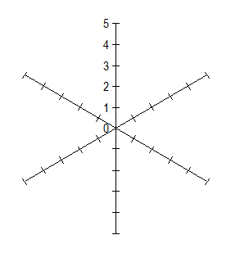

Discussion questions:
Which sensory characteristic received the highest rating?
Which sensory characteristic received the lowest rating?
Were you surprised by any of the results?
What was your overall sensory appreciation of the dish like?
Visit this website to find out some adjectives to describe foods:
http://archive.foodafactoflife.org.uk/attachments/ee816658-1eed-4b1756de6e61.pdf

