Written Activity One

The Bodies Response to Appetite and Satiety
Add notes to the diagram below that explain the body’s physiological response to appetite and satiety.

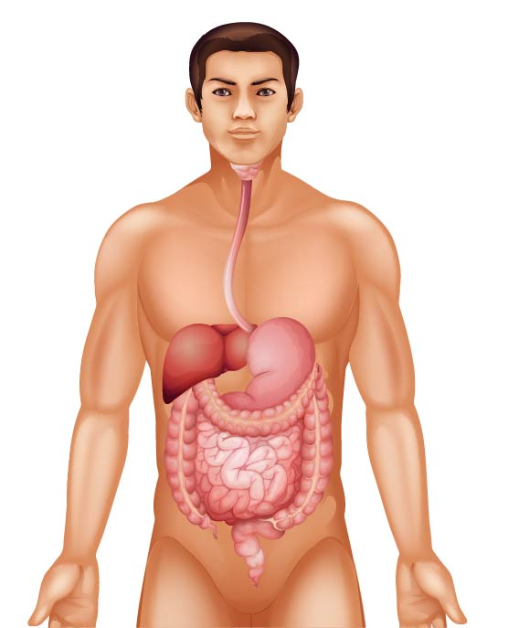

Written Activity Two

What are the Most Filling Foods?
Read the article at this link: https://www.medicalnewstoday.com/articles/324078#takeaway
In the table below, list four different ingredients you would include in a meal.
Explain why each of the foods in this meal contributes to satiety.
Food | Why does this food contribute to satiety?

Written Activity Three

Describing the Senses
We use our five senses when we decide to eat a portion of food. These senses are hearing, sight, smell, taste, and touch. Our senses help us evaluate food, develop personal food preferences, and make choices. It is important to avoid using terms like delicious, nice, and scrumptious when describing foods. These adjectives say how much you like food, not why you like it. When describing food, it is important to use words about sensory properties, including taste, texture, appearance, aroma, and sound.
Think of your most and least favourite dish.
Describe the taste, texture, appearance, aroma, and sound of these dishes in the table below.
Dishes | Taste | Texture | Appearance | Aroma | Sound
Most favourite dish
Least favourite dish
Visit this website to find out some adjectives to describe foods:
http://archive.foodafactoflife.org.uk/attachments/ee816658-1eed-4b1756de6e61.pdf

