Practical Activity One

As Sweet as Sugar
Sugar-sweetened beverages include flavoured milk, fruit juices, soft drinks, cordials, meal replacement shakes, sports and energy drinks, water or flavoured water, and coffee or tea sweetened with sugar.
Intensely sweetened beverages contain food additives added to drinks or food to replace the sweet taste of sugar and lower its energy value. They are often promoted as diet, reduced-sugar, or low in sugar products. Some intensely sweetened beverages contain artificial sweeteners, including aspartame, saccharin, and sucralose. Others contain a highly concentrated extract found naturally in some plants, including stevia and monk fruit extract.
The graph below represents the consumption of selected sugar-sweetened and intense-sweetened beverages by month from July 2018 to June 2021.
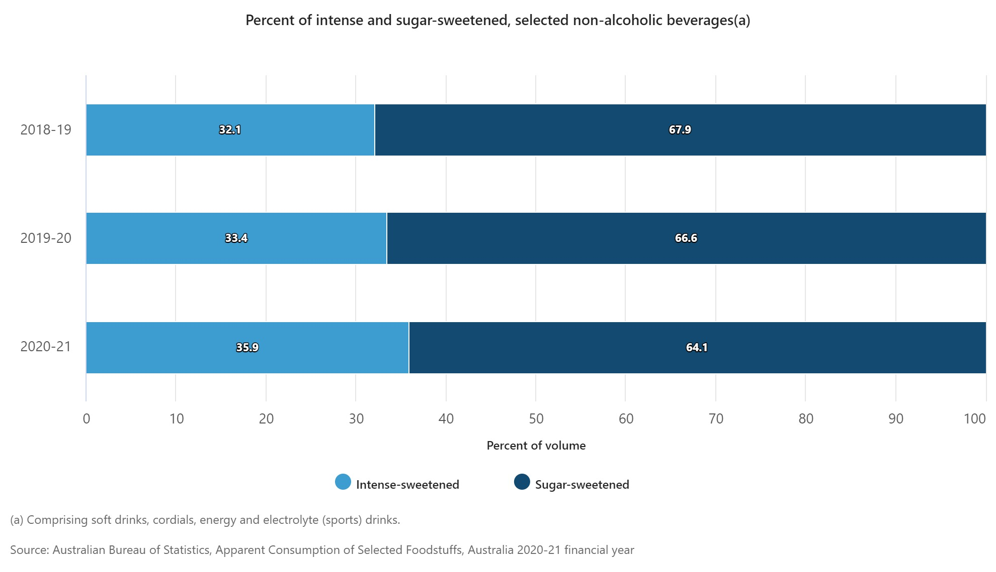
Source: Australian Bureau of Statistics (2020-2021) ‘Percent of intense and sugar-sweetened, selected non-alcoholic beverages(a), Apparent consumption of Selected Foodstuffs, Australia, 11 September 2022.
Answer the following questions:
- Using the data provided, identify any recent developments, changes, and trends in the consumption of intense-sweetened and sugar-sweetened beverages from 2018 to 2021.
- Provide a possible reason for these recent developments, changes, and trends.

Bubble Challenge!
Bubble tea is an incredibly unique-looking Asian beverage made by blending a tea base with milk, fruit, and fruit juices, with added “bubbles.” Traditionally the bubbles are made using tapioca; however, a lot of sugar is used to make it this way. Another way of making these bubbles is from fruit juice. A local company would like you to design a drink with popping bubbles of fruit juice called ‘Popping Boba’ without added sugar. They have entrusted you with their secret recipe for popping bubbles of juice.
Popping Boba Bubbles!
Ingredients:
1 cup fruit juice, no added sugar  ½ teaspoon sodium alginate |  | 1 cup water  1 teaspoon calcium lactate
Method:
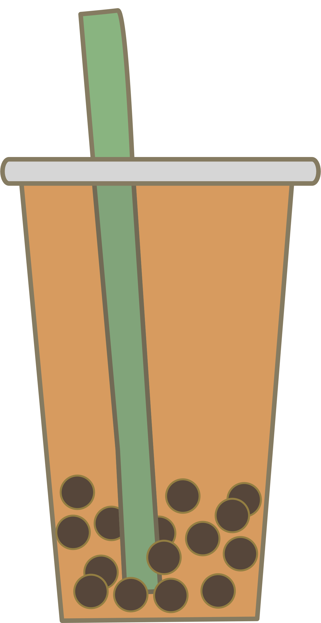
- Collect and measure ingredients.
- Mix the fruit juice with sodium alginate, and whisk until thoroughly dissolved.
Alternatively, you could mix in a blender, but you will need to leave it to stand for several hours in the fridge until the bubbles disperse.
- Mix the water with the calcium lactate until it dissolves.
- Fill a syringe with some of the fruit juice mixture.
- Slowly release some of the fruit juice into the water mixture.
Make sure they are covered with water.
Make sure you are not too far from the water mixture, or the bubbles will turn out stringy; too close, and the bubbles will harden too quickly.
- Scoop the bubbles of fruit juice out of the water using a sieve.
- When making fruit or milk bubble drinks, combine your favourite fruits and/or tea into a smoothie drink and add the Popping Bobas.
Order Form
Select the ingredients you want to use to make your Popping Boba drink.
Select 190ml of cold tea: | Select 65ml of milk: |  | Select ¼ cup of two fruits:
- Jasmine Green Tea | - Low fat cow’s milk |  | - Strawberries | - Blueberries
- Earl Grey Tea | - Almond Milk |  | - Mango | - Pineapple
- Green Tea | - Soy Milk |  | - Banana
- Chamomile Tea | - Lactose-Free Milk |  | - Peaches

