Exam Preparation
Section A - Multiple Choice Questions (5 marks)
Question 1
Which statement supports manufacturers in marketing their packaged food as 'healthy'?
- People are becoming more interested in environmental and ethical food products.
- There may be an increase in the number of people seeking convenient food products who are health conscious.
- An increasing number of women in paid employment are looking for quick and easy meals to prepare.
- People are cooking less and seeking packaged food.

Question 2
A popular and credible television series, Landline, published a news article stating, "A survey of more than 900 cafes found a quarter of Australians chose plant milk in 2021 and that the most popular option was almond, followed by soy and oat.'
This expanding market could be due to:
- Café owners catering to consumers who do not believe animals should be killed for food.
- Consumers who have an allergy to nuts ordering more plant-based milk.
- A rise in the number of people seeking dairy alternatives.
- The promotion of plant-based meats in magazines.
Refer to the graph below to answer Questions 3, 4 and 5

Source: CSIRO, 2020. CSIRO study reveals COVID-19's impact on weight and emotional wellbeing. [Online]
Available at: https://www.csiro.au/en/news/news-releases/2020/csiro-study-reveals-covid-19s-impact-on-weight-and-emotional-wellbeing, [Accessed 11 September 2022].

Question 3
Identify the incorrect statement:
- A significant number of people reduced their vegetable intake during the COVID19 pandemic.
- Fewer people consumed takeaway food during this period time.
- Everyone ate the same amount of fruit they usually ate during this time.
- Around half the population surveyed continued to eat about the same number of home-cooked meals.
Question 4
The data in this graph supports the theory that:
- More people were shopping locally.
- Everyone was snacking more throughout the day.
- People may have snacked on food for comfort during the pandemic.
- People cooked a lot of snack food during the pandemic.

Question 5
If Australian eating patterns continue in this trend, then it is likely that:
- People may purchase and consume more vegetables than they did before the pandemic.
- People may be more inclined to prepare a meal from scratch than buy takeaway meals for dinner.
- There may be more healthy snack products for sale at the supermarket.
- All of the above.

Section B – Short Answer Responses (10 marks)
Question 1 (4 marks)

According to the National Retail Association, more than 50 per cent of Australian shoppers want to buy locally sourced and produced products.
This figure demonstrates a change in the pattern of purchasing and consumption behaviour of Australian consumers.
Describe two reasons that could explain the increase in Australian shoppers wanting to buy locally sourced and produced products.
Reason One
Reason Two

Question 4 (6 marks)
Study the graph below.
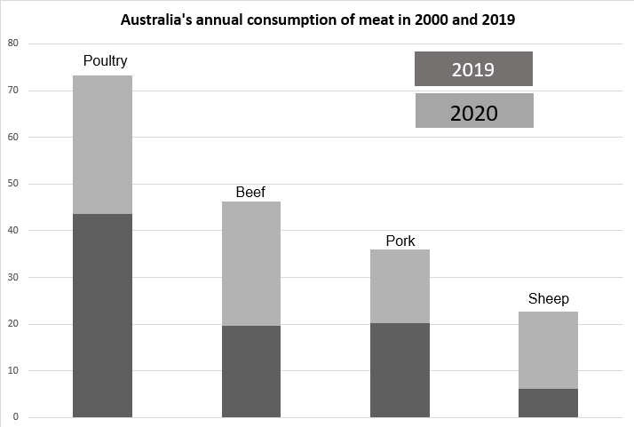
Source: Bogueva, D., Whitton, C., Phillips, C. & Marinova, D., 2021. The Conversation, How much meat do we eat? New figures show 6 countries have hit their peak. [Online]
Available at: https://theconversation.com/how-much-meat-do-we-eat-new-figures-show-6-countries-have-hit-their-peak-172507 [Accessed 12 September 2022].
- In the table below, use the data to identify two trends in this graph. (2 marks)
- Discuss a possible reason for each trend identified. (4 marks)
Trends | Possible Reasons

