Exam Preparation
Section A - Multiple Choice Questions (5 marks)
Question 1
People can improve their mental health by:
- Eating a wide variety of food.
- Earning more income.
- Consuming a variety of different coloured and types of fruits and vegetables.
- Including fats in their diet.
The answer is not A. The question states eating a wide variety of food but does not specify that the food needs to be healthy.
The answer is not B. Earning a higher income may not necessarily result in someone consuming more nutritious food. Earning a higher income may also result in a person exercising less, working longer hours and experiencing more stress.
The answer is C. Eating various coloured and types of fruits and vegetables can improve mental health.
The answer is not D. Not all types of fats promote mental health. Omega three fatty acids assist with mental health.
Question 2
A diet high in sugar can be linked to:
- Difficulty in concentration and tiredness.
- Improved mood.
- An ability to cope in stressful situations.
- Improved general wellbeing.
The answer is A. People with high sugar levels in the blood are likely to be tired and have difficulty focusing.
The answer is not B, C, or D. A diet high in sugar has a negative impact on mental health, not a positive impact.
Question 3
Which of the following meals is most likely to contribute to positive mental wellbeing:
- Spicy noodles with green vegetables.
- Fried basmati rice served with kimchi and a garden salad, topped with nuts.
- Pasta salad.
- Chicken schnitzel with mashed potato and three vegetables.
The answer is not A. This seems to be a nutritious meal but does not contain various coloured vegetables. It is not the most likely meal to contribute to positive mental wellbeing.
The answer is B. This meal contains low GI basmati rice, kimchi with probiotics, a garden salad that contributes to variety, and nuts containing Omega 3. All of the foods contribute to positive mental wellbeing.
The answer is not C. More information about the pasta salad needs to be provided to determine if it will contribute to positive mental wellbeing.
The answer is not D. More information about the meal needs to be provided to determine if it will contribute to positive mental wellbeing.
Question 4
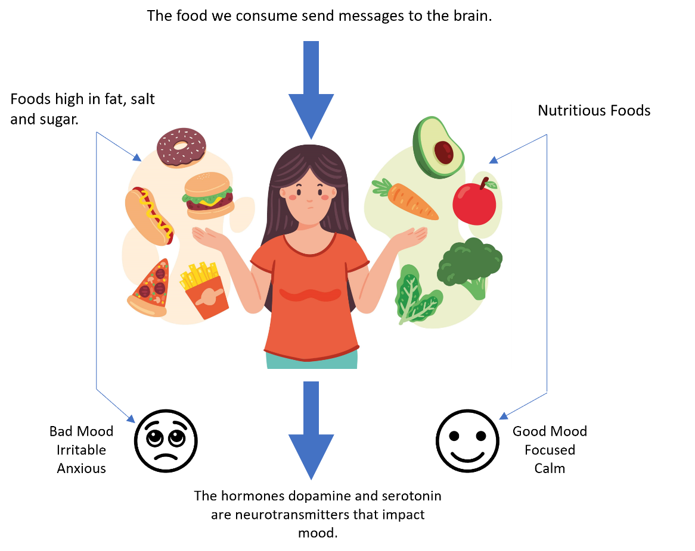
The diagram above shows that:
- Consuming healthy foods causes high levels of irritability and anxiety.
- Consuming unhealthy foods triggers the reward section of the brain to produce neurotransmitters.
- Increasing the consumption of nutritious foods can promote positive mental health.
- Eating promotes positive self-esteem.
The answer is not A. The diagram links irritability and anxiety with consuming foods high in fat, salt, and sugar.
The answer is not B. The diagram does not mention the reward centre of the brain.
The answer is C. The diagram makes a direct link between nutritious foods and a good mood.
The answer is not D. Eating does not always promote positive self-esteem.
Question 5
Consuming which of the following are considered beneficial to mental wellbeing?
- Antioxidants, omega-3 fats, probiotics, prebiotics, and protein-rich foods.
- Antioxidants, saturated fats, and protein-rich foods.
- Fat, salt and sugar.
- All of the above.
The answer is A. All of these foods contribute to positive mental wellbeing.
The answer is not B. Omega-3 fats contribute to positive mental wellbeing, not saturated fats.
The answer is not C. Fat, salt and sugar do not contribute to positive mental wellbeing.
The answer is not D.

Section B – Short Answer Responses (20 marks)
Question 1 (3 marks)
Fish Salad Ingredients:
- Fish | - Lemon | - Lettuce | - tomatoes
- Olive oil | - Nuts and seeds | - Yoghurt | - Butter
- Identify one ingredient in the fish salad that has a positive influence on mental health. (1 mark)
For 1 mark, the student needed to identify one ingredient in the salad that influences mental health.
Any one of the following responses were accepted:
Fish, olive oil, nuts and seeds, and yoghurt.
- Explain why consuming this ingredient can influence mental health. (2 marks)
For 2 marks, the student needed to breifly explain why fish, olive oil, nuts and seeds are beneficial to mental wellbeing.
One of the following responses was accpeted:
Fish, olive oil, nuts and seeds contain omega 3. Omega 3 alleviates the symptoms of depression and other mental illnesses as well as enhancing mental wellbeing.
Or
Fish contains protein, proteins can help with the production of serotonin which helps people relax and dopamine which is known as a feel good hormone.
Or
Yoghurt can contain probiotics. Probiotics have a positive impact on the central nervous system and could play a role in easing anxiety and depression.
Note: The Food Studies Study Design states that students need to know the role of food in influencing mental health and undersrand the links between food, behaviours and effects on health and wellbeing. Therefore, it is unlikely students will need to explain why these foods impact mental health in detail. The text provided covers this in detail to help students understand the concept. However, it is unlikely they will need to know this content in this level of depth.
Question 2 (2 marks)
Explain why eating a wide variety of nutritious food is important for positive mental health. (2 marks)
For 2 marks, the student needed to explain why eating a wide variety is important for positive mental health.
A wide variety of fruits and vegetables contain a variety of antioxidants. Consuming brightly coloured fruits and vegetables high in antioxidants may help prevent these problems and increase the amount of dopamine and serotonin the body produces.

Question 3 (10 marks)
Study the ingredients for the Salmon Buddha Bowl with Zesty Herb Dressing for One or Two below:
Salmon Buddha Bowl with Zesty Herb Dressing for One
Salmon Buddha Bowl Ingredients:  1 Australian Salmon Skin-On Fillet  1 tablespoon olive oil  ½ wholemeal cous cous  1 teaspoon finely grated lemon rind  50g rocket leaves  ¼ red cabbage  4 asparagus stalks  1 tablespoon pepitas (pumpkin seeds)  1 tablespoon sunflower seeds  1 teaspoon pine nuts | Zesty Herb Dressing for One:  1-2 tablespoons flat-leaf parsley, chopped  1 tablespoon dill, chopped  ½ - 1 small garlic clove, peeled and halved  1 tablespoon Greek-style yoghurt  1 tablespoon homemade mayonnaise  2 teaspoons lemon juice
Source: https://www.taste.com.au/recipes/salmon-buddha-bowl-zesty-herb-dressing-recipe/ppwr8qws
- Identify five ingredients in this meal that positively impact mental health. (5 marks)
The student was awarded one mark for each correct response (up to five).
Any of the following were accepted.
Salmon, olive oil, cous cous, lemon, rocket leaves, red cabbage, asparagus, pepitas, pine nuts, and Greek-style yoghurt.
- Modify this recipe to ensure it is suitable for someone with wheat intolerance. (2 marks)
The student was awarded one mark for identifying the ingredient that contained wheat.
Cous cous contains wheat.
The student was awarded an additional mark for suggesting one substitution.
Any of the following grains were accepted.
Buckwheat, farro, millet, rice, sorghum, teff, and quinoa could be used as a substitute.
- i). Identify one social factor that might influence a person's decision to make this recipe. (1 mark)
The student was awarded one mark for identifying one social factor.
The student must use the social factors from the study design, for example, money was not accepted.
Any of the following social factors were accepted:
Accommodation, available time, cultural norms, education, income and location.

ii). Explain why this social factor might influence a person's decision to make this recipe. (2 marks)
Any of the following answers were accepted.
Accommodation – someone with limited kitchen facilities, perhaps just a stove, might make this recipe as there is no other heating appliance needed except a stove. Other than the salmon and grains, everything else is served fresh.
Available Time – The only ingredients that need to be cooked in this recipe are the salmon and cous cous. Both of these ingredients take little time to cook. The remaining ingredients are served fresh. Someone could make this dish who has limited available time to prepare and cook food.
Cultural Norms – This might be a family's regular dish each week. This could be part of a special weeknight ritual/ meal. (It is difficult to provide an answer for cultural norms; therefore, it is best to select a social factor that better applies to the recipe.
Education – People who have had some education about nutrition and cooking might be more inclined to make this meal because they understand the benefits of the ingredients for mental health.
Income – Salmon tends to be an expensive ingredient. People on a limited income might be unable to afford to make this dish or have to substitute the salmon for something cheaper, like frozen fish.
Location – People who live near the sea or on a salmon farm might make this dish because it may be easier for them to obtain salmon.

