Written Activity One

Contexts for Gaining Food Knowledge and Skills
A range of contexts in which food knowledge and skill development. Websites are a common context for people to gain food information and skills.
In small groups, select one of the websites below:
- Dairy Australia: https://www.dairy.com.au/
- Meat and Livestock Australia HealthyMeals Website: https://www.mlahealthymeals.com.au/
- Nutrition Australia: https://nutritionaustralia.org/
- Dieticians Association of Australia: https://dietitiansaustralia.org.au/
- Diabetes Australia: https://www.diabetesaustralia.com.au/
- Live Lighter Campaign: https://livelighter.com.au/
- Rethink your Sugary Drink: https://www.rethinksugarydrink.org.au/
- Tryfor5: https://www.tryfor5.org.au/
- Nutrition Plus: https://www.nutritionplus.org.au/

What website did you choose?
What food knowledge and skills does this website provide? | How does having this food knowledge and skills benefit individuals, families, and the community?

Written Activity Two

Fad Foods or Trends
Select one of the food fads or trends discussed in the articles listed below.
- https://www.choice.com.au/food-and-drink/nutrition/sugar/articles/sweeteners
- https://www.choice.com.au/food-and-drink/dairy/milk/buying-guides/milk-alternatives
Answer the following questions:
- What are the different varieties of this food fad or trend that are available for purchase?
- Why might this food fad or trend be increasing in popularity?
- What kind of evidence-based information was used? How reliable was it?
- Was the data that was used accurate? Why? Why not?
- Were the sources of information used in the article credible? Why? Why not?
- Would you believe the information in this article? Justify your decision.

Written Activity Three

Fad Diets
Select one of the fad diets at this link: https://utswmed.org/medblog/diets-best-and-worst/
Complete the SWOT analysis of this fad diet with the Australian Guide to Healthy Eating in the chart below:
Strengths | Weaknesses
How is this diet similar to the Australian Guide to Healthy Eating?  Does the diet promote a wide range of food?  Are all five food groups included? | How is this diet different from the Australian Guide to Healthy Eating?  Does the diet restrict the amount of food available?
Opportunities | Threats
What opportunities might people who follow the diet have?  Are they still able to socialise easily when on the diet? | What problems might arise from going on this diet?  How could this diet impact health in the long term?
What kind of evidence-based information would need to be used to determine the validity of this diet?
Make a statement about the nutritional efficacy of this diet.
Discuss the nutritional efficacy of this diet with the Australian Guide to Healthy Eating.

Written Activity Four

Fad Diet Forum Post
Read the forum post below and advise what the poster should do.
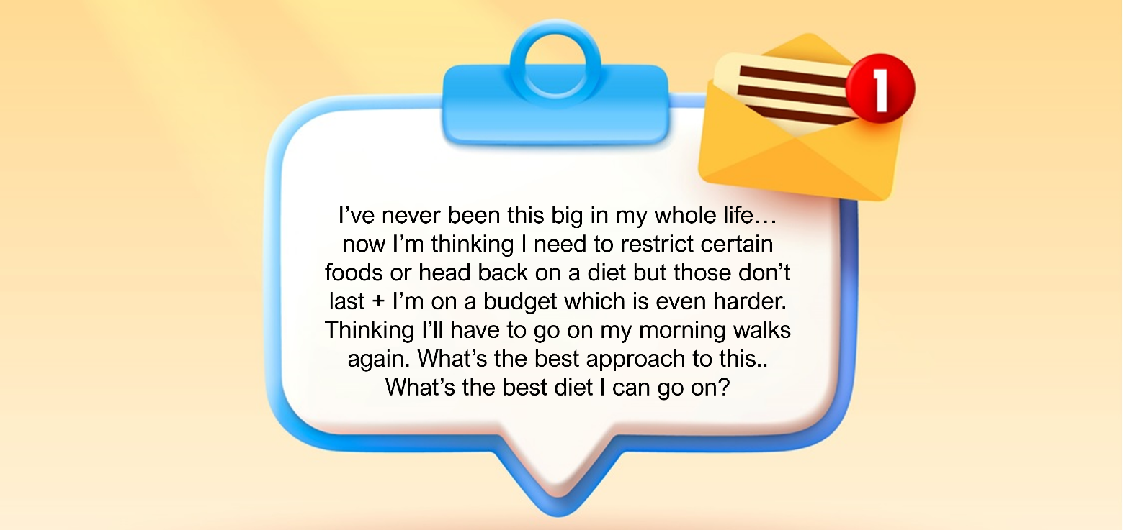
Provide some advice on how the forum poster should find the best diet.
In your answer, refer to the three principles of evidence-based research used in the development of the Australian Dietary Guidelines and the Australian Guide to Healthy Eating and how they can be applied to contemporary fad diets.

