Exam Preparation
Section A - Multiple Choice Questions (5 marks)
Question 1
Which of the following best describes the term microbiota?
- A group of microorganisms that live on or in us.
- Microorganisms that inhabit the large intestine only.
- The microorganisms that feed the good bacteria in the gut.
- Foods that contain microorganisms.
The answer is A; microbiota are microorganisms; they live on or in us.
The answer is not B; microbiota refers to a group of microorganisms that are found just about everywhere on the human body.
The answer is not C; prebiotics feed the good bacteria in the gut.
The answer is not D; they are microorganisms.
Question 2
Where does most microbiota live in the human body?
- The mouth.
- The small intestine.
- The large intestine.
- The stomach.
The answer is C; microbiota can be found in all the areas listed, however, significant amounts can be found in the large intestine.
Question 3
During microbial fermentation, resistant starch is broken down into:
- Soluble fibre.
- Insoluble fibre
- Prebiotics and probiotics.
- Short-chain fatty acids.
The answer is not A or B; soluble and insoluble fibre are broken down (fermented) by microbiota in the large intestine into short-chain fatty acids.
The answer is not C; resistant starch is an excellent source of prebiotics.
The answer is D; due to fermentation, resistant starch is broken down into short-chain fatty acids.

Question 4
Which of the following foods promote the growth and health of the microbiota?
- Berries, bananas, dairy products, and onion flavoured chips.
- Garlic, dairy foods, kombucha, store-bought sauerkraut.
- Unripe bananas, garlic and cold potatoes.
- All of the above.
The foods that promote the growth and health of the microbiota are prebiotics.
The answer is not A. Berries and unripe bananas are good sources of prebiotics. Dairy products are sources of probiotics. Store-bought flavoured chips are unlikely to provide either prebiotics or probiotics.
The answer is not B. Garlic is a source of prebiotics. Dairy foods and kombucha are sources of probiotics. Store-bough sauerkraut is unlikely to provide probiotics.
The answer is C; unripe bananas, garlic and cold potatoes are all sources of prebiotics.
The answer is not D.
Question 5
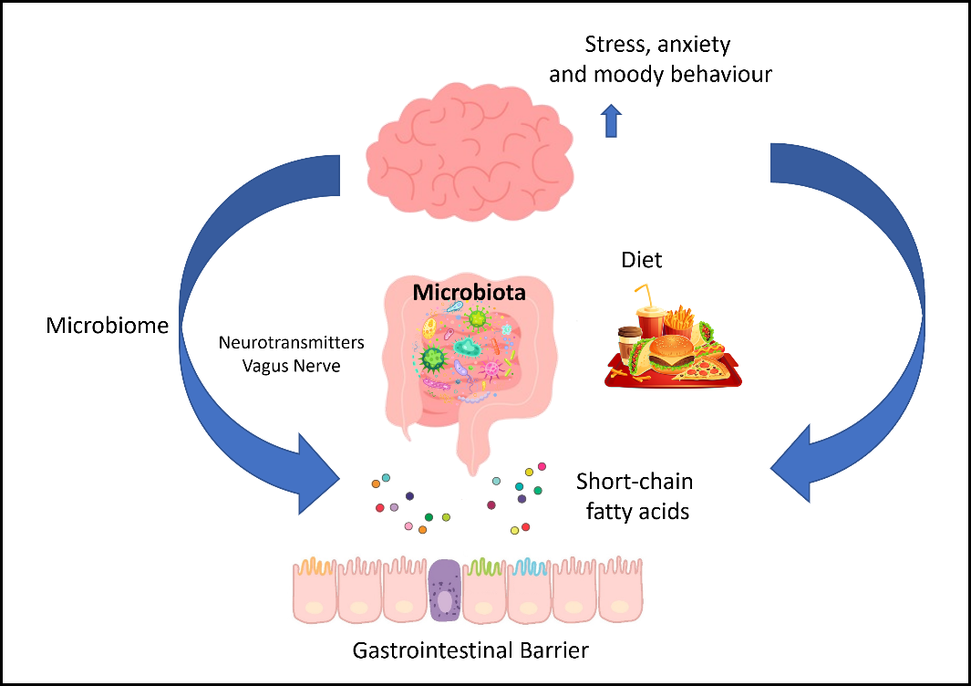
Which one of the statements is best supported by the diagram above?
- The gastrointestinal tract does not influence the psychological response to fast food.
- There is a complex relationship between food intake, microbiota in the gut and mental health.
- Neurotransmitters found in fast food impact behaviour.
- A healthy microbiome improves mental health.
The answer is not A; fast food does influence a psychological response.
The answer is B; the relationship between food intake, microbiota, the gut and mental health are all represented in the diagram above.
The answer is not C; the diagram indicates that neurotransmitters, along with the vagus nerve, play a role in the microbiome. There is no indication that they are found in food.
The answer is not D; the diagram indicates that stress, anxiety and moody behaviour are increased, not decreased. The diagram focuses on the negative impact that fast food has on mental health.

Section B – Short Answer Responses (17 marks)
Question 1 (8 marks)
There has been a recent increase in demand for prebiotic and probiotic food products in Australia due to people wanting to improve their physical health.
- Explain the difference between the roles of prebiotics and probiotics in the body. 2 marks
For full marks, the student needed to compare the differences between the roles of prebiotics and probiotics in the body. Using the term ‘whereas’ or a similar word when comparing prebiotics and probiotics was preferred.
For two marks, the student needed to explain differences between prebiotics and probiotics.
They only needed to state one role for prebiotics and one thing for probiotics.
Explanations where students stated that prebiotics were non-living and probiotics were living things or bacteria did not relate/ answer the question.
Prebiotics are food substances that promote the growth and health of the microbiota, whereas probiotics are bacteria add variety to the existing microbiota in the gut.
- In response to the information above, describe two reasons that could explain the increase in demand for probiotic food products in Australia. 4 marks
Reason One
For full marks, the student needed to respond to the information above by explaining why prebiotic foods improve physical health. Reasons relating to mental health were not accepted because mental health was not mentioned in the stimuli.
For full marks, both reasons must have been related to probiotics.
One of the following responses about probiotics could include:
- Probiotics increase the variety and quantity of microbiota in the gut and can help the body to fight disease-causing pathogens like viruses.
- Probiotics help to reduce inflammation in the body.
- Probiotics can assist in disease prevention.
- Probiotics can assist in synthesising and absorbing vitamins.
- Probiotics can help control blood sugar levels and diabetes.
- Probiotics can assist with digestive health and help prevent constipation and diarrohea.
Reason Two
See above responses.
- The Australian Guide to Healthy Eating (part of the ‘Eat for Health’ program) recommends eating a wide variety of different types and coloured foods.
Explain why eating a variety of plant foods will help support gut microbiota. 2 marks
For two marks, students needed to explain why consuming a wide variety of different coloured and types of plant foods was important.
Any one of the following answers was acceptable.
Different coloured and types of fruits and vegetables will improve gut health by encouraging the growth of different microorganisms.
Different coloured and types of fruits and vegetables contain lots of fibre which feed some bacteria in the gut and stimulate their growth.
Different coloured and types of fruits and vegetables contain different types of bacteria. This adds variety to the gut bacteria in a persons gut.
Question 2 (4 marks)
A magazine has advertised this recipe as a suitable picnic option for people seeking to improve their gut health.
Cannellini Bean, Potato and Zucchini Fritatta Slice
Ingredients: | Method:
1 small zucchini, grated  ½ onion, grated  1 small potato, 1cm cubes  ½ x 310g can cannellini beans, drained & rinsed  25 grams tasty cheese, grated  ½ cup self-raising flour  3 eggs, lightly beaten  2 tablespoons olive oil  ¼ teaspoon salt  1 tablespoon Greek Yoghurt  Pinch of sweet paprika | - Collect and prepare ingredients.  - Grease and line a 17 x 27 slice tin.  - Preheat the oven to 180°C.  - Place zucchini, onion, potato, cheese and flour in a large bowl. Mix well.  - Combine eggs, oil and salt.  - Stir into the zucchini mixture.  - Pour the mixture into the prepared tin.  - Bake in the oven for 30 minutes or until firm and golden in colour.  - Remove from the oven and set aside for 15 minutes.  - Refrigerate until cold.  - Cut into 16 triangles and serve cold with a dollop of plain Greek Yoghurt sprinkled with sweet paprika.
Identify two ingredients in this slice that may help someone improve their gut health and explain why these foods might improve gut health.
Students needed to show an understanding of the foods that contain prebiotics, probiotics and dietary fibre.
They needed to identify two foods that contained prebiotics, probiotics and dietary fibre. (2 marks)
They needed to explain why these foods would help improve gut health.(2 marks)
Any of the two ingredients and explanations below were accepted.
Ingredient | Explanation/ Assessment
Cold potato | A cold potato contains more resistant starch compared to a hot potato.
Yoghurt | Plain Greek yoghurt contains probiotics.
Cannellini beans | Cannellini beans are an excellent source of resistant starch.
Zucchini | Many vegetables, such as zucchini contain resistant starch.

Question 3 (5 marks)
In 2012, Deakin University conducted the first randomised controlled trial investigating the relationship between diet and mental health. It confirmed that a healthy diet could effectively improve the mental health of people with depression. Participants in the program were divided into two groups. Half of the participants attended a social support group to assist with their depression. The other group received the dietary intervention. The study concluded in 2015.
The diagram below shows the dietary model used by the group following the dietary intervention.
Source: https://www.deakin.edu.au/research/impact-stories/improving-mood-with-food#:~:text=Deakin%20University's%20SMILES%20trial%20(Supporting,health%20of%20people%20with%20clinical
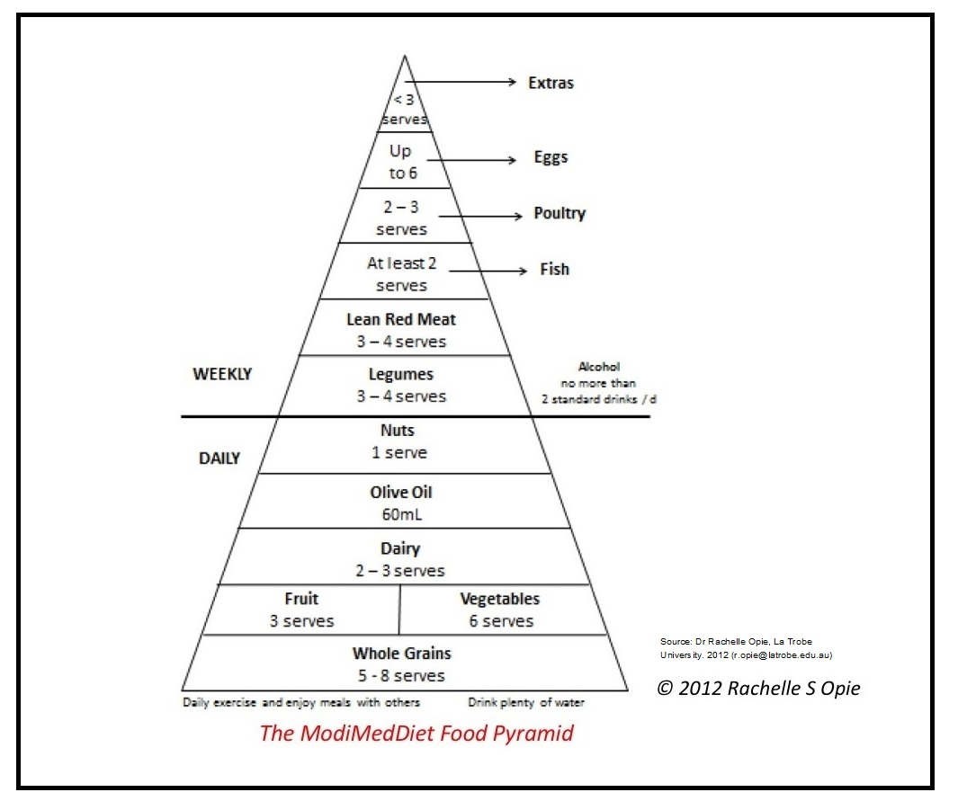
Referring to the information and diagram above, explain why researchers who conducted the study concluded that eating a healthy diet could improve a person’s mental wellbeing.
In the study conducted by researchers at Deakin University, some participants were asked to follow a healthy eating program that involved eating a set number of serves of foods each day or each week. Other participants were required to participate in a social group counselling session. The participants who followed the eating recommendations noticed an improvement in their depression compared to the group that participated in the counselling sessions.
The people on the healthy eating program were likely required to eat 5 to 8 serves of whole grains, three serves of fruit and six serves of vegetables per day. They were also asked to consume 3 to 4 serves of legumes per week. These foods contain different types of dietary fibre, which include soluble fibre, insoluble fibre and resistant starch. This dietary fibre contains indigestible carbohydrates. The good bacteria in the large intestine break down or ferments the indigestible carbohydrates into short-chain fatty acids. The short-chain fatty acids produced by the fermentation of dietary fibre feed the gut microbiota, resulting in a healthier gut microbiome.
Millions of neurons can be found in the intestinal walls of the gut; these neurons link the gut to the nervous system and vagus nerve. Any disruption or imbalance in the gut's microbiota may cause problems with the nervous system and the messages the vagus nerve sends to the brain. This may influence mental health.
In addition, there is a possible link between the ‘feel-good’ hormones, serotonin and dopamine, with the gut. The gut microbiota can make these hormones in much larger quantities than the brain. The healthier the gut microbiome is, the more likely these hormones will be produced. In addition to this, short-chain fatty acids, created when fermenting dietary fibre, help to release serotonin. By consuming a nutritious diet, a person is more likely to produce hormones that positively impact mental health.
Marks for this question were based on the rubric below:
Mark | Criteria
5 marks | The student:  - Referred to the information and diagram in their response.  - Gave a clear accurate explanation that showed a thorough understanding about the role of dietary fibre in the gut health.  - Gave a clear explanation that showed a thorough about how the gut and brain were linked and how this impact mental wellbeing.
4 marks | The student:  - Referred to the information and diagram in their response.  - Gave a clear accurate explanation that showed a good understanding about the role of dietary fibre in the gut health.  - Gave a clear explanation that showed a good about how the gut and brain were linked and how this impact mental wellbeing.
3 marks | The student:  - Referred to the information or diagram in their response.  - Gave a clear accurate explanation that showed an adequate understanding about the role of dietary fibre in the gut health.  - Gave a clear explanation that showed an adequate understanding about how the gut and brain were linked and how this impact mental wellbeing.
2 marks  Limited | The student:  - Referred to the information or diagram in their response.  - Gave a basic explanation that showed some understanding of the role of dietary fibre in the gut health.  - Gave a basic explanation that showed some underestanding about how the gut and brain were linked.
1 mark  Very Limited | The student:  - Made no reference to the information or diagram in their response.  - Gave a very limited response that showed very little understanding of the role of dietary fibre in the gut health.  Or  - Gave a very limited response that showed very little underestanding about how the gut and brain were linked.
0 marks | Response was irrelevant or did not answer the question.

