Exam Preparation

Multiple-Choice Questions (5 marks)
Choose the response that is correct or that best answers the question.
- A new type of pita bread wrap has recently been advertised at the supermarket.
The advertising on the food package states, “High in Fibre.”
- This is an example of a nutrition content claim.
- This is an example of a high-level health claim.
- This is an example of a health nutrition claim.
- This is an example of a general-level health claim.
The answer is A. This is a nutrient content claim because these claims are about the content of a certain nutrient or substance in a food.
The answer is not B. The claim mentions a nutrient or substance in a food or the food itself, but it does not say its relationship to a serious disease or a biomarker of a serious illness.
The answer is not C. There is no such thing as a health nutrient claim. The correct term is health claim. There are two types of health claims, general level health claims and high level health claims.
The answer is not D. The claim mentions a nutrient or substance in a food or the food itself, but it does not mention its effect on health. Therefore, the claim cannot be a general-level health claim.
- A general-level health claim describes:
- A relationship between the nutrient and energy content of the food.
- A relationship between the consumption of food and a lifestyle disease.
- The amount of nutrients or probiotics present in a food.
- A relationship between a nutrient or substance in a food, or the food itself, and its effect on health.
The answer is not A. Any reference to a food's nutrient and/or energy content would be a nutrient-content claim.
The answer is not B. Any reference to a nutrient and a serious disease or a biomarker of a serious disease is classified as a high-level health claim.
The answer is not C. Any reference to the level or amount of a nutrient or substance, such as probiotics, is classified as a nutrient content claim.
The answer is D. A claim referring to a food, nutrient or substance and its impact on health is a general-level health claim. However, if the claim refers to a serious disease or a biomarker of a serious disease, then it is classified as a high-level health claim.
- Which of the following information helps people compare and select food?
- Country of origin labelling.
- Health star ratings.
- List of ingredients.
- All of the above.
The answer is D. All of the responses are true.
The country of origin labelling helps people compare and select food based on the origin of their ingredients.
The health star rating allows people to compare the nutritional value of similar food products.
The list of ingredients enables people to compare the ingredients in food products.
- Identify the term food marketers might use on food labels and advertising to appeal to people who avoid foods containing additives and preservatives.
- Natural.
- Fat-free
- Low-Sodium
- Lite
The answer is A. The term ‘natural’ implies that the food does not contain additives or preservatives. However, FSANZ does not regulate the word ‘natural.’
The answer is not B. A food product with the term ‘fat-free’ on the label or in the advertisement is likely to appeal to people who want to lose weight.
The answer is not C. A food product with the term ‘low-sodium’ on the label or in the advertisement is likely to appeal to people at risk of heart disease.
The answer is not D. The term ‘lite’ on a food advertisement or food label can refer to the lightness of taste, colour, fat or salt content.
- The nutrition information panel on a food label provides consumers with the skills to:
- Determine the ingredients used in a food product.
- Safely prepare the food.
- Compare the food product with other similar food products.
- All of the above.
The answer is not A. The nutrition information panel allows consumers to compare nutrients in a food product, not ingredients.
The answer is not B. A nutritional information panel does not provide preparation instructions.
The answer is C. The nutritional information panel allows consumers to compare the nutrients in food products to determine which meets their nutritional needs.
The answer is not D.

Short Answer Questions (10 marks)
Question 1 (4 marks)
A new milk marketed to children is claimed to be ‘a good source of calcium.’
Explain why ‘a good source of calcium’ is considered a nutrition content claim and not a health claim.
For two marks, the student needed to define the two terms.
For one mark, the student needed to compare the two terms.
For one mark, the student needed to refer to the nutrient content claim in the question.
The student did not have to refer to the stimulus in their response.
A suitable response could have been:
A ‘good source of calcium’ is considered a nutrition content claim as it is a statement about the amount of a nutrient in the milk. This statement is not a health claim as no relationship between the consumption of the nutrient in the milk and the health benefit it can provide has been made; for example, ‘calcium is important for the development of strong bones’ would be considered a health claim.
Question 2 (3 marks)
Identify one marketing term in the food advertisement below that relates to the quality of the food.
Explain why manufacturers may have used this term.
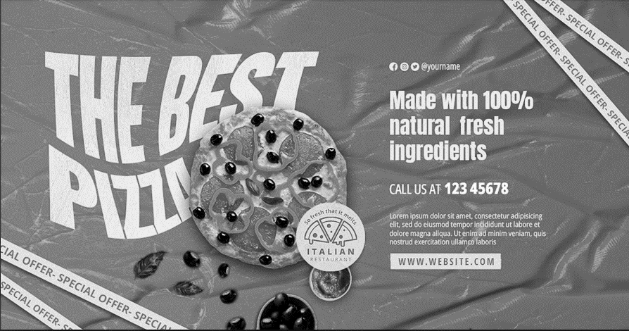
For one mark, the student needed to identify a marking term used in the advertisement that related to the quality of the food.
For two marks, the student needed to explain why marketers may use this term.
Some possible responses include:
The word ‘fresh’ implies that the food is wholesome and healthy because it is fresh. It implies that the vegetables on the pizza have been recently picked.
This term encourages people to buy the product because they associate the word ‘fresh’ with healthy food.
Or
The word ‘natural’ implies that the food is wholesome and healthy. It might imply that the vegetables on the pizza have been made without adding any preservatives or artificial colours. People may be more likely to buy products with this wording than those without the wording.
This term encourages people to buy the product because they associate the word ‘natural’ with healthy food. Buying healthy food might make people feel good about themselves, so they are more likely to purchase this product.
Question 3 (3 marks)
Describe how technological innovations in food labelling could be used to help people prepare food.
For one mark, students needed to identify one-way innovation in technology can be used to help people prepare food.
For two marks, students needed to describe how this technological innovation can help people prepare food.
Some food manufacturers have put a QR code on their food products. Food preparation instructions are then provided via the QR code.

